

**NAILS ART**

**E-Project Documentation**

**Teacher Name: SIR KAIF**

**APTECH COMPUTER EDUCATION**

**LATIFABAD PAKISTAN**

**Issue Date: 22-4-25**

TABLE OF CONTENT

|  |  |  |
| --- | --- | --- |
| **S No** | **Contents** | **Page No** |
| 01 | Certificate | 3 |
| 02 | Acknowledgement | 4 |
| 03 | Project Report | 5 |
| 04 | Problem Definition | 6 |
| 05 | Customer Requirements Specification  (CRS) | 7 |
| 06 | Architecture Design of the Project | 8 |
| 07 | System Requirement | 9 |
| 08 | Task Sheet | 10 |
| 09 | Project Plan | 11 |
| 10 | Checklist of work Progress | 12 |
| 11 | Final Check List | 13 |
| 12 | Screen Shots | 14 |
| 13 | Source Code | 16 |

CERTIFICATE

This is to certify that

**Syed Airaf,**

**Mubashir,**

**Eshal,**

Submitted by:

**ALL GROUP MEMBERS**

Has successfully Designed

**Nail Art**

Date of Issue: 22**-19-24**

Authorized Signature: SIR Kaif

ACKNOWLEDGEMENT

First and foremost, we would like to express our deep gratitude and most heartfelt thanks to almighty ALLAH for his blessings, for lightening up our heart with the torch of knowledge and for giving us the ability to complete this project.

We would like to thanks Aptech Worldwide and the team of E-Project for their generous support and clarifying the doubts regarding e-project. We would like to acknowledge the way of explanation which the team of e-project gave in e-project to make website and we are equally grateful to our teacher (SIR RAJESH) for giving us a moral support and guiding us different matters regarding project in all the time about the research and writing of this project.

We are greatly indebted to Aptech Worldwide, SIR RAJESH, Faculty Members and ACE Hyderabad, Pakistan for encouragement and incessant help.

PROJECT REPORT

**BY:**

**Student1623497 Syed Airaf,**

**Student1623769 Mubashir Hassan,**

**Student1616245 Eshal,**

Project Title:

Nail Art

Members Name:

Syed Airaf,

Mubashir Hassan,

Eshal,

Batch Code: 2411E

Start Date: 30-Mar -2025

End Date: 21-Apr -2025

Course: ACCP-PRIME (HDSE-1)

Teacher: SIR Kaif

Center Manager: Sir Shoaib Ahmed

Center Academic Head: Sir Shoaib Ahmed

Center Name: LATIFABAD, Pakistan

Submitted as

E Project Documentation

**OBJECTIVES & AIM**

The Objective of this program is to give a sample project to work on real life

projects. These applications help you build a larger more robust application.

The objective is not to teach you the software’s but to provide you with a real life

scenario and help you create basic applications using the tools.

You can revise the topics before you start with the project.

These programs should be done in the Lab sessions with assistance of the faculty if

required.

It is very essential that a student has a clear understanding of the subject.

Kindly get back to projects Team in case of any doubts regarding the

application or its objectives.

**PROBLEM STATEMENT**

**Introduction**

The problem statement is attached separately in a file “FurnitureSystem.doc”

**Standards plan:**

Every code block must have comments.

The logic of the program needs to be explained. Proper documentation should be

maintained.

Complete Project Report along with synopsis, code and documentation should be

prepared.

**Documentation**

No project is complete without documentation. In fact, it is one of the most

important activities during the development of a project. The documentation of an

ideal project will be in the form of a project report comprising of the following

documents:

`

* Certificate of Completion.
* Table of Contents.
* Problem Definition.
* Customer Requirement Specification.
* Project Plan.
* E-R Diagrams.
* Algorithms.
* GUI Standards Document.
* Interface Design Document.
* Task Sheet.
* Project Review and Monitoring Report.
* Unit Testing Check List.
* Final Check List.

**Deliverables**

**You need to submit the following Deliverables:**

**1. Documentation of the project.**

**2.You need to follow all the following points as a part of your**

**projects execution process**

**a) Send us 2 (two) projects status mail, each should be after 10**

**days interval from your projects start date. Incase if your project**

**is less than 30 days then also you need to send 2 (two) status**

**mails (first status mail between 7-10 days and second 3 days**

**before the end date of project).**

**b) The status mail should consist of description with review document**

**(what's going on the project). Also you can send your doubts / clarification or**

**any additional inputs required to complete your project any time during the**

**project planning and execution.**

**c) At the time of project submission also send us the feedback along**

**with your documentation (soft copy). The Feedback form is**

**attached with this mail.**

Architecture & Design of the Project:

Since the website will have client architecture it will have one-tier architecture.

System Requirement:

**Hardware/ Software Requirements**

**Hardware**

* A minimum computer system that will help you access all the tools in the courses is a Pentium 166 or better
* 64 Megabytes of RAM or better

**Software *[Either or Combination as per Course/Sem]***

* Notepad/HTML editor/Coffee Cup
* Angular / Angular JS / React / Bootstrap
* Dreamweaver / Figma
* MS IE / Chrome / FireFox / Netscape /MS Edge

TASK SHEET

|  |  |  |  |  |  |
| --- | --- | --- | --- | --- | --- |
| **Project Ref. No:** | | **Date of Preparation of Activity Plan:** | | | |
| Sr.no | Task | Actual  Start Date: | Actual  Day: | Team  Mates Names: | Status: |
| 01 | Meeting | 30Mar 2025 | 1 | Syed Airaf,  Mubashir |  |
| 02 | Data  Collection | 2Apr, 2025 | 1 | Syed Airaf,  Mubashir |  |
| 03 | Designing  Home  Page | 5 Apr,2025 | 3 | Syed Airaf,  Mubashir |  |
| 04 | Linking | 11 Apr, 2025 | 1 | Syed Airaf,  Mubashir |  |
| 05 | Check  Links | 14,Apr, 2025 | 1 | Syed Airaf,  Mubashir |  |
| 06 | Navbar | 15,Apr, 2025 | 1 | Syed Airaf,  Mubashir |  |
| 06 | Finalizing | 18,Apr, 2025 | 2 | Syed Airaf,  Mubashir |  |
| 08 | Documentation | 19,Apr, 2025 | 1 | Syed Airaf,  Mubashir |  |
| 09 | Uploading | 21,Apr, 2025 | 4 | Syed Airaf,  Mubashir |  |

PROJECT PLAN

* Website is able to execute quickly.
* The color combination of our website is so attractive.
* The collection of data is authentic and taken by the most popular product websites.
* Background of each page is as same as the main page.
* The contact page is well prepared exactly for the same page as user clicks on the link...
* A user can resolve its difficulties easily from this site.

CHECK LIST OF WORK PROGRESS

|  |  |  |
| --- | --- | --- |
| **SR. No** | **Aspect Tested** | **Remarks** |
| 01 | Data Collection |  |
| 02 | Designing Home Page |  |
| 03 | Linking The Pages |  |
| 04 | Designing Other Pages |  |
| 05 | Finalization |  |
| 06 | Documentation |  |

FINAL CHECK LIST

|  |  |  |  |
| --- | --- | --- | --- |
| **SR.No** | **Particulars** | **Yes** | **No** |
| 01 | Do all pages open? | YES |  |
| 02 | Are all hyperlinks working? | YES |  |
| 03 | Are the web page contents devoid for  spelling mistakes? |  | No |
| 04 | Are all the web components working? | YES |  |
| 05 | Is site browser compatible? | YES |  |

SCREEN SHOTS:

HOME PAGE

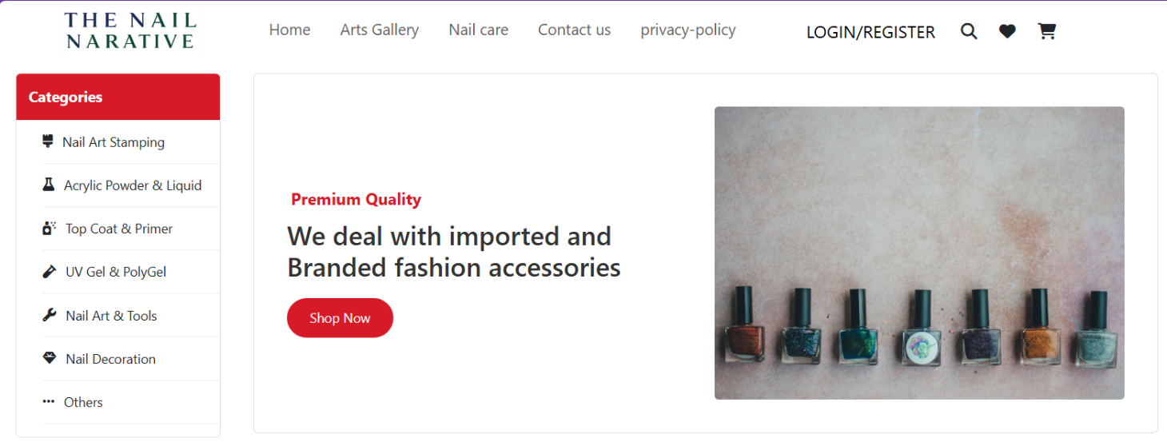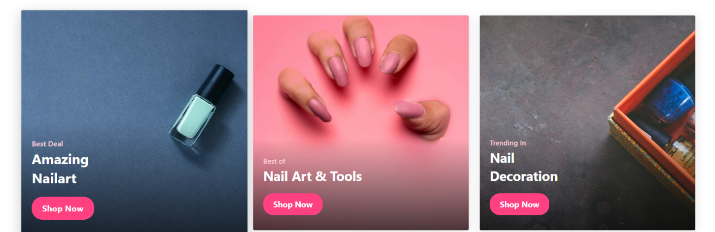

# 

Arts Gallery

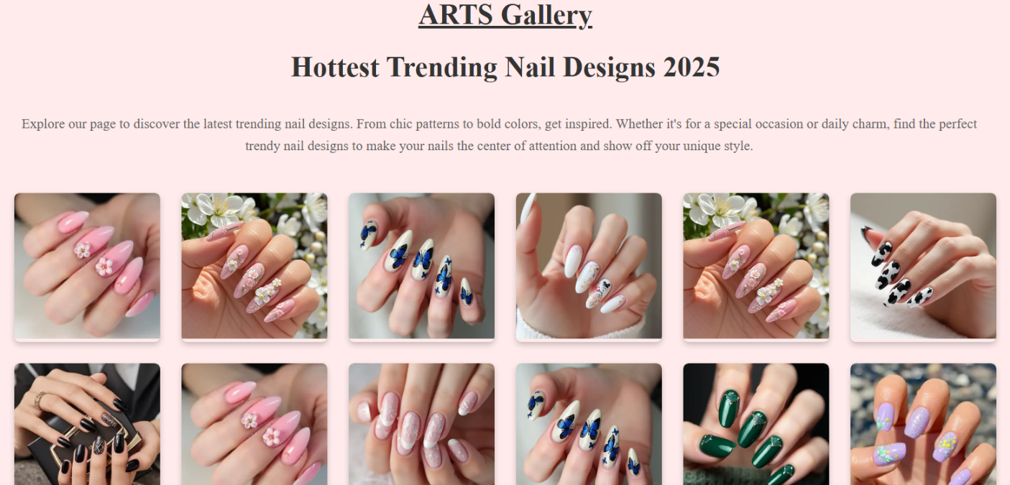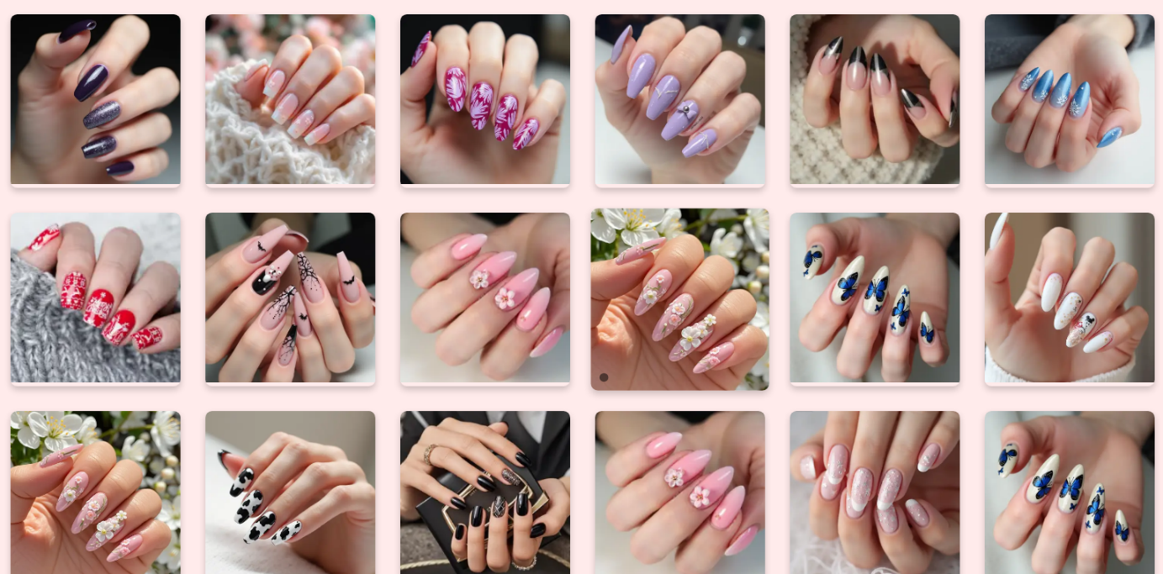

SPICES PAGE

SOURCE CODE:

HTML : HOME PAGE

<!DOCTYPE html>

<html lang="en">

<head>

    <meta charset="UTF-8">

    <meta name="viewport" content="width=device-width, initial-scale=1.0">

    <title>Document</title>

    <link rel="stylesheet" href="style.css">

    <link href="https://cdn.jsdelivr.net/npm/bootstrap@5.0.2/dist/css/bootstrap.min.css" rel="stylesheet"

        integrity="sha384-EVSTQN3/azprG1Anm3QDgpJLIm9Nao0Yz1ztcQTwFspd3yD65VohhpuuCOmLASjC" crossorigin="anonymous">

    <script src="https://cdn.jsdelivr.net/npm/bootstrap@5.0.2/dist/js/bootstrap.bundle.min.js"

        integrity="sha384-MrcW6ZMFYlzcLA8Nl+NtUVF0sA7MsXsP1UyJoMp4YLEuNSfAP+JcXn/tWtIaxVXM"

        crossorigin="anonymous"></script>

    <link rel="stylesheet" href="https://cdnjs.cloudflare.com/ajax/libs/font-awesome/6.7.2/css/all.min.css"

        integrity="sha512-Evv84Mr4kqVGRNSgIGL/F/aIDqQb7xQ2vcrdIwxfjThSH8CSR7PBEakCr51Ck+w+/U6swU2Im1vVX0SVk9ABhg=="

        crossorigin="anonymous" referrerpolicy="no-referrer" />

   <style>

   </style>

</head>

<body>

    <div class="container">

        <div class="row">

            <div class="col">

                <div class="nave">

                    <img height="60px" src="Capture the.PNG " alt="alo">

                    <div class="aa">

                        <li><a href="check.html" target="_blank" style="list-style: none; text-decoration:none; color:rgb(104, 94, 94);">Home</a></li>

                        <li><a href="arts gallery.html" target="_blank" style="list-style: none; text-decoration:none; color:rgb(104, 94, 94);">Arts Gallery</a></li>

                        <li><a href="check.html" target="_blank" style="list-style: none; text-decoration:none; color:rgb(104, 94, 94);">Nail care</a></li>

                        <li><a href="check.html" target="_blank" style="list-style: none; text-decoration:none; color:rgb(104, 94, 94);">Contact us</a></li>

                        <li><a href="check.html" target="_blank" style="list-style: none; text-decoration:none; color:rgb(104, 94, 94);">privacy-policy</a></li>

                    </div>

                    <div class="bb">

                        <button id="openBtn">LOGIN/REGISTER</button>

                    </div>

                    <div class="icon">

                        <p><i class="fa-solid fa-magnifying-glass"></i></p>

                        <p><i class="fa-solid fa-heart"></i></p>

                        <p><i class="fa-solid fa-cart-shopping"></i></p>

                    </div>

                </div>

            </div>

        </div>

</div>

<!-- <div class="statici">

    <p><i class="fa-brands fa-facebook"></i></p>

    <p><i class="fa-brands fa-whatsapp"></i></p>

    <p><i class="fa-brands fa-youtube"></i></p>

</div> -->

<div class="layout">

    <div class="sidebar_main">

      <div class="sidebar-header">Categories</div>

      <ul class="category-list">

        <li><i class="fa-solid fa-brush"></i> Nail Art Stamping</li>

        <li><i class="fa-solid fa-flask"></i> Acrylic Powder & Liquid</li>

        <li><i class="fa-solid fa-spray-can-sparkles"></i> Top Coat & Primer</li>

        <li><i class="fa-solid fa-vial"></i> UV Gel & PolyGel</li>

        <li><i class="fa-solid fa-wrench"></i> Nail Art & Tools</li>

        <li><i class="fa-solid fa-gem"></i> Nail Decoration</li>

        <li><i class="fa-solid fa-ellipsis-h"></i> Others</li>

      </ul>

    </div>

    <main class="main-content">

      <div class="hero-section">

        <div class="hero-text">

          <p class="highlight">Premium Quality</p>

          <h1>We deal with imported and<br>Branded fashion accessories</h1>

          <button class="shop-btn">Shop Now</button>

        </div>

        <div class="hero-image">

          <img src="https://static.thehoneycombers.com/wp-content/uploads/sites/2/2020/05/nail-polish-diy-manicure.png" alt="Nail polishes" />

        </div>

      </div>

    </main>

  </div>

<div id="sidebar" class="sidebar">

    <a href="javascript:void(0)" class="close-btn" id="closeBtn">&times;</a>

    <h2 class="h2 ">Sign Up</h2>

    <form action="#" method="POST">

        <label for="username">Username:</label>

        <input type="text" id="username" name="username" required><br><br>

        <label for="email">Email:</label>

        <input type="email" id="email" name="email" required><br><br>

        <label for="password">Password:</label>

        <input type="password" id="password" name="password" required><br><br>

        <button class="sign">Sign Up</button>

    </form>

</div>

<div class="cards">

    <div class="card">

        <img src="qx46ajis.png" alt="image">

        <div class="overlay">

            <h6>Best Deal</h6>

            <h2>Amazing</h2>

            <h2>Nailart</h2>

            <button>Shop Now</button>

        </div>

    </div>

    <div class="card">

        <img src="gg3u8k9b.png" alt="image">

        <div class="overlay">

            <h6>Best of</h6>

            <h2>Nail Art & Tools</h2>

            <button>Shop Now</button>

        </div>

    </div>

    <div class="card">

        <img src="4kgsbiog.png" alt="image">

        <div class="overlay">

            <h6>Trending In</h6>

            <h2>Nail</h2>

            <h2>Decoration</h2>

            <button>Shop Now</button>

        </div>

    </div>

</div>

<footer>

    <div class="foot-logo">

        <img src="Capture the.PNG" alt="logo">

    </div>

    <div class="disc">

        <p>We provide nail art n fashion accessories at your doorstep, pay cash at the time of delivery, place your order on our website.</p>

        <a href="">Nail Art Supplies, Sindh Hyd unit 10</a>

        <a href="">Housing Society,Hyderabad, 54000</a>

        <a href="">Phone: +923314044154</a>

        <a href="">Araf7arad@gmail.com</a>

    </div>

    <div class="catagorize">

        <h1>Top Categories</h1>

        <ul>

        <li>Nail Art Stamping</li>

        <li>Acrylic Powder & Liquid</li>

        <li>Top Coat Basecoat & Primer</li>

        <li>UV Gel & PolyGel</li>

        <li>Nail Decoration</li>

        <li>Nail Art Tools</li>

        <li>Otheres</li>

    </ul>

    </div>

    <div class="links">

        <h1>Useful Links</h1>

        <a href="">Home</a>

        <a href="">Arts Gallery</a>

        <a href="">Nail care</a>

        <a href="">Contact us</a>

        <a href="">privacy-policy</a>

    </div>

</footer>

<script>

   const openBtn = document.getElementById('openBtn');

const closeBtn = document.getElementById('closeBtn');

const sidebar = document.getElementById('sidebar');

openBtn.addEventListener('click', () => {

    sidebar.style.width = '300px';

});

closeBtn.addEventListener('click', () => {

    sidebar.style.width = '0';

});

</script>

</body>

</html>

HTML : ARTs Gallery

<!DOCTYPE html>

<html lang="en">

<head>

    <meta charset="UTF-8">

    <meta name="viewport" content="width=device-width, initial-scale=1.0">

    <title>\ARTS Gallery</title>

    <link rel="stylesheet" href="style.css">

</head>

<body>

    <div class="container_arts">

    <div class="styx">

        <h1 style="text-decoration: underline;">ARTS Gallery</h1>

<h1>Hottest Trending Nail Designs 2025</h1>

<p>Explore our page to discover the latest trending nail designs. From chic patterns to bold colors, get inspired. Whether it's for a special occasion or daily charm, find the perfect trendy nail designs to make your nails the center of attention and show off your unique style.</p>

    </div>

    <div class="arts">

        <div class="art-item">

            <img src="arts/bfc5ffef5df44535be5928564cd27872.webp" alt="imgage">

<div class="nail-name"> </div>

<!-- yeh name kaye liye banya tha but boht sari images hyn to confuse nahi hona|^^| -->

        </div>

        <div class="art-item">

            <img src="arts/c5f3e2568d8a428283f929fb734285ee.webp" alt="imgage">

            <div class="nail-name"> </div>

        </div>

        <div class="art-item">

        <img src="arts/bd79d236a779418bbaad9fe08c463406.webp" alt="imgage">

        <div class="nail-name"> </div>

        </div>

        <div class="art-item">

            <img src="arts/c4615bfd48a94ac795f450879cfcd973.webp" alt="imgage">

<div class="nail-name"> </div>

        </div>

        <div class="art-item">

            <img src="arts/c5f3e2568d8a428283f929fb734285ee.webp" alt="imgage">

<div class="nail-name"> </div>

        </div>

        <div class="art-item">

            <img src="arts/cca1ff0b9cd849c69db40f2ddb919f93.webp" alt="imgage">

        </div>

        <div class="art-item">

            <img src="arts/e811f0d77fad48c380c9c567db446fff.webp" alt="imgage">

<div class="nail-name"> </div>

        </div>

        <div class="art-item">

            <img src="arts/bfc5ffef5df44535be5928564cd27872.webp" alt="imgage">

<div class="nail-name"> </div>

        </div>

        <div class="art-item">

            <img src="arts/e6ddf28fa4d746d298ff47f9a82f1c36.webp" alt="imgage">

<div class="nail-name"> </div>

        </div>

        <div class="art-item">

            <img src="arts/bd79d236a779418bbaad9fe08c463406.webp" alt="imgage">

<div class="nail-name"> </div>

        </div>

        <div class="art-item">

            <img src="arts/9268cf90645049e793a476e0f77f70a6.webp" alt="imgage">

<div class="nail-name"> </div>

        </div>

        <div class="art-item">

            <img src="arts/91636bd72a6d43b3a9f90ced0644c89e.webp" alt="imgage">

<div class="nail-name"> </div>

        </div>

        <div class="art-item">

            <img src="arts/8e9dfaac3a3547e7b21fc9ae2d6e1af5.webp" alt="imgage">

<div class="nail-name"> </div>

        </div>

        <div class="art-item">

            <img src="arts/85251dde42dc4e99b9b1ce30d46b68b9.webp" alt="imgage">

<div class="nail-name"> </div>

        </div>

        <div class="art-item">

            <img src="arts/4fab7b3f96e94771b399c407f563fa7e.webp" alt="imgage">

<div class="nail-name"> </div>

        </div>

        <div class="art-item">

            <img src="arts/340fa273185649bcbe6088cf47fa5de7.webp" alt="imgage">

<div class="nail-name"> </div>

        </div>

        <div class="art-item">

            <img src="arts/3b6439120ef5477790ff30c14d73126a.webp" alt="imgage">

<div class="nail-name"> </div>

        </div>

        <div class="art-item">

            <img src="arts/2ed75432996540678276fc6a75c9ed2a.webp" alt="imgage">

<div class="nail-name"> </div>

        </div>

        <div class="art-item">

            <img src="arts/24a617780a5346718a260fb331a35d94.webp" alt="imgage">

<div class="nail-name"> </div>

        </div>

        <div class="art-item">

            <img src="arts/1c5d1f714f1d420fb17016de4d3f876b.webp" alt="imgage">

<div class="nail-name"> </div>

        </div>

        <div class="art-item">

            <img src="arts/bfc5ffef5df44535be5928564cd27872.webp" alt="imgage">

<div class="nail-name"> </div>

        </div>

        <div class="art-item">

            <img src="arts/c5f3e2568d8a428283f929fb734285ee.webp" alt="imgage">

            <div class="nail-name"> </div>

        </div>

        <div class="art-item">

        <img src="arts/bd79d236a779418bbaad9fe08c463406.webp" alt="imgage">

        <div class="nail-name"> </div>

        </div>

        <div class="art-item">

            <img src="arts/c4615bfd48a94ac795f450879cfcd973.webp" alt="imgage">

<div class="nail-name"> </div>

        </div>

        <div class="art-item">

            <img src="arts/c5f3e2568d8a428283f929fb734285ee.webp" alt="imgage">

<div class="nail-name"> </div>

        </div>

        <div class="art-item">

            <img src="arts/cca1ff0b9cd849c69db40f2ddb919f93.webp" alt="imgage">

        </div>

        <div class="art-item">

            <img src="arts/e811f0d77fad48c380c9c567db446fff.webp" alt="imgage">

<div class="nail-name"> </div>

        </div>

        <div class="art-item">

            <img src="arts/bfc5ffef5df44535be5928564cd27872.webp" alt="imgage">

<div class="nail-name"> </div>

        </div>

        <div class="art-item">

            <img src="arts/e6ddf28fa4d746d298ff47f9a82f1c36.webp" alt="imgage">

<div class="nail-name"> </div>

        </div>

        <div class="art-item">

            <img src="arts/bd79d236a779418bbaad9fe08c463406.webp" alt="imgage">

<div class="nail-name"> </div>

        </div>

        <div class="art-item">

            <img src="arts/9268cf90645049e793a476e0f77f70a6.webp" alt="imgage">

<div class="nail-name"> </div>

        </div>

        <div class="art-item">

            <img src="arts/91636bd72a6d43b3a9f90ced0644c89e.webp" alt="imgage">

<div class="nail-name"> </div>

        </div>

        <div class="art-item">

            <img src="arts/8e9dfaac3a3547e7b21fc9ae2d6e1af5.webp" alt="imgage">

<div class="nail-name"> </div>

        </div>

        <div class="art-item">

            <img src="arts/85251dde42dc4e99b9b1ce30d46b68b9.webp" alt="imgage">

<div class="nail-name"> </div>

        </div>

        <div class="art-item">

            <img src="arts/4fab7b3f96e94771b399c407f563fa7e.webp" alt="imgage">

<div class="nail-name"> </div>

        </div>

        <div class="art-item">

            <img src="arts/340fa273185649bcbe6088cf47fa5de7.webp" alt="imgage">

<div class="nail-name"> </div>

        </div>

        <div class="art-item">

            <img src="arts/4fab7b3f96e94771b399c407f563fa7e.webp" alt="imgage">

<div class="nail-name"> </div>

        </div>

        <div class="art-item">

            <img src="arts/340fa273185649bcbe6088cf47fa5de7.webp" alt="imgage">

<div class="nail-name"> </div>

        </div>

        <div class="art-item">

            <img src="arts/3b6439120ef5477790ff30c14d73126a.webp" alt="imgage">

<div class="nail-name"> </div>

        </div>

        <div class="art-item">

            <img src="arts/2ed75432996540678276fc6a75c9ed2a.webp" alt="imgage">

<div class="nail-name"> </div>

        </div>

        <div class="art-item">

            <img src="arts/24a617780a5346718a260fb331a35d94.webp" alt="imgage">

<div class="nail-name"> </div>

        </div>

        <div class="art-item">

            <img src="arts/1c5d1f714f1d420fb17016de4d3f876b.webp" alt="imgage">

<div class="nail-name"> </div>

        </div>

    </div>

</div>

</body>

</html>

All Code CSS

 .nave {

    display: flex;

    text-align: center;

    align-items: center;

    list-style: none;

    padding: 0px 5px 0 5px;

    gap: 20px;

    text-decoration: none;

    list-style: none;

}

.container{

/* position:sticky;

top: 0; */

/* background-color: rgb(243, 0, 0); */

max-width: 200vw;

}

a {

    color: black;

    text-decoration: none;

    list-style: none;

}

.aa {

    display: flex;

    /* width: 100px; */

    gap: 36px;

    font-size: 19px;

    margin-left: 60px;

    margin-right: 60px;

}

.aa :hover {

    text-decoration: underline;

    color: red;

}

.bb button {

    border: none;

    background-color: white;

    font-size: 21px;

    padding-top: 9px;

}

.bb button:hover {

    text-decoration: underline;

    color: red;

}

p {

    font-size: 20px;

    position: relative;

    left: 5px;

    padding-top: 22px;

    padding-right: 27px;

}

.icon {

    display: flex;

}

.statici{

    display: flex;

    position:fixed;

    top: 500px;

}

.statici p{

    font-size: 30px;

}

.fa-facebook{color: blue;}

.fa-whatsapp{color: green;}

.fa-youtube{color: red;}

/* sidebar */

.sidebar {

height: 100%;

width: 0;

position: fixed;

z-index: 1;

top: 0;

right: 0;

background-color: #111;

overflow-x: hidden;

transition: 0.5s;

padding-top: 60px;

color: white;

/* padding-left: 20px; */

}

.sidebar a {

padding: 8px;

text-decoration: none;

font-size: 25px;

color: white;

display: block;

transition: 0.3s;

}

.sidebar a:hover {

color: #f1f1f1;

}

.sidebar form {

margin-top: 20px;

}

.sidebar input {

width: 100%;

padding: 8px;

margin-bottom: 10px;

/* padding-left: 10px;*/

/* margin-left: 15px; */

/* margin-right: 10px; */

}

.h2{

position: relative;

left: 110px;

}

.sign button{

position: relative;

left: 100px;

}

/* Close button styles */

.close-btn {

font-size: 36px;

position: absolute;

top: 0;

left: 10px;

}

.cards {

    display: flex;

    flex-wrap: wrap;

    justify-content: center;

    gap: 20px;

    padding: 20px;

}

.card {

    position: relative;

    width: 430px;

    overflow: hidden;

    border-radius: 20px;

    box-shadow: 0 4px 20px rgba(0, 0, 0, 0.1);

    transition: transform 0.4s ease, box-shadow 0.4s ease;

    cursor: pointer;

}

.card img {

    width: 100%;

    height: auto;

    display: block;

    transition: transform 0.4s ease;

}

.card:hover {

    transform: scale(1.05);

    box-shadow: 0 8px 25px rgba(0, 0, 0, 0.2);

}

.overlay {

    position: absolute;

    bottom: 0;

    left: 0;

    right: 0;

    padding: 30px 20px;

    background: linear-gradient(to top, rgba(0,0,0,0.7), transparent);

    color: white;

    text-align: left;

    transition: background 0.4s ease;

}

.overlay h6 {

    font-size: 14px;

    color: #ffd1dc;

    margin: 5px 0;

}

.overlay h2 {

    margin: 5px 0;

    font-size: 26px;

    font-weight: bold;

}

.overlay button {

    margin-top: 15px;

    padding: 10px 20px;

    background-color: #ff4081;

    border: none;

    border-radius: 20px;

    color: white;

    font-weight: bold;

    cursor: pointer;

    transition: background-color 0.3s ease;

}

.overlay button:hover {

    background-color: #e91e63;

}

.container_arts{

    width: 100;

    margin: 0 auto;

    background-color: #ffd1d170;

}

.styx h1 {

    text-align: center;

    font-size: 2.5rem;

    color: #333;

    margin-bottom: 20px;

}

.styx{

    /* background-color: papayawhip; */

}

.styx p {

    text-align: center;

    font-size: 1.2rem;

    color: #666;

    line-height: 1.6;

    margin-bottom: 30px;

}

.arts {

    display: grid;

    grid-template-columns: repeat(auto-fill, minmax(200px, 1fr));

    gap: 30px;

    padding: 20px;

    /* background-color: rgba(255, 192, 203, 0.349); */

}

.art-item {

    position: relative;

    overflow: hidden;

    border-radius: 8px;

    box-shadow: 0 4px 8px rgba(0, 0, 0, 0.2);

    transition: transform 0.3s ease;

}

.art-item img {

    width: 100%;

    height: auto;

    transition: transform 0.3s ease;

}

.art-item:hover img {

    transform: scale(1.1);

}

.art-item:hover {

    transform: scale(1.05);

}

.nail-name {

    position: absolute;

    bottom: 10px;

    left: 10px;

    font-size: 1.5rem;

    color: white;

    background-color: rgba(0, 0, 0, 0.5);

    padding: 5px;

    border-radius: 5px;

    font-weight: bold;

    visibility: hidden;

}

.art-item:hover .nail-name {

    visibility: visible;

}

.layout {

    display: flex;

    position: relative;

  }

  /* Sidebar */

  .sidebar_main {

    width: 250px;

    background-color: #fff;

    border: 1px solid #e0e0e0;

    margin: 20px;

    border-radius: 5px;

  }

  .sidebar-header {

    background-color: #d71a28;

    color: #fff;

    padding: 15px;

    font-weight: bold;

    font-size: 18px;

    border-top-left-radius: 5px;

    border-top-right-radius: 5px;

  }

  .category-list {

    list-style: none;

  }

  .category-list li {

    padding: 14px 0px;

    display: flex;

    align-items: center;

    gap: 12px;

    border-bottom: 1px solid #eee;

    cursor: pointer;

  }

  .category-list li:hover {

    background-color: #f6f6f6;

  }

  /* Main content */

  .main-content {

    flex-grow: 1;

    margin: 20px;

  }

  .hero-section {

    display: flex;

    justify-content: space-between;

    align-items: center;

    padding: 40px;

    border: 1px solid #e0e0e0;

    border-radius: 5px;

    background-color: #fff;

  }

  .hero-text {

    max-width: 50%;

  }

  .highlight {

    color: #d71a28;

    font-weight: bold;

    margin-bottom: 10px;

  }

  .hero-text h1 {

    font-size: 32px;

    font-weight: 600;

    color: #333;

    margin-bottom: 20px;

  }

  .shop-btn {

    background-color: #d71a28;

    color: #fff;

    padding: 12px 28px;

    border: none;

    font-size: 16px;

    border-radius: 25px;

    cursor: pointer;

    transition: background-color 0.3s ease;

  }

  .shop-btn:hover {

    background-color: #b51220;

  }

  .hero-image img {

    max-width: 500px;

    width: 100%;

    border-radius: 5px;

  }

    /* Footer */

  footer {

  background-color: #000;

  color: #fff;

  display: flex;

  flex-wrap: wrap;

  justify-content: space-around;

  padding: 40px 20px;

  font-family: Arial, sans-serif;

}

footer .foot-logo img {

  width: 120px;

  margin-bottom: 20px;

}

footer div {

  max-width: 300px;

  margin: 10px;

}

footer h1 {

  font-size: 18px;

  margin-bottom: 10px;

  color: #f0c040;

}

footer p {

  margin-bottom: 10px;

  line-height: 1.6;

}

footer a {

  display: block;

  color: #ccc;

  text-decoration: none;

  margin: 5px 0;

  transition: color 0.3s ease;

}

footer a:hover {

  color: #fff;

}

footer ul {

  padding-left: 20px;

  list-style-type: disc;

}

footer li {

  margin: 5px 0;

}